ERFWeb Expense Verifier Guide
Nov 5, 2026 · @Jay Bryan
When Finance doubts a line on an approved report, an Expense Verifier checks it and records one finding.

Before you start
Sign in at the ERFWeb address with your ER System username and password, in Chrome or Edge. The left menu shows Verifications under Work queues. You get a text and an email when Finance sends a line you may verify, and again when Level 2 decides on a line you found Not verified. Keep your mobile number and email up to date with the System Administrator.
- You check facts: was the meal, trip or receipt real and right? You never change amounts, approve, return or reject.
- You record one finding per request; it cannot be changed afterwards.
- You never verify your own report, a report you approved, or a request you raised. Those are left out of your pool.
- You see a report only while it has a request in the open pool or one you picked up.

Step 1: Pick up a request
The Verifications page has three tabs:
Tab | What it lists
Open | Requests from Finance that nobody has picked up yet
In progress | Requests you picked up and have not finished
My findings | Requests you recorded a finding on
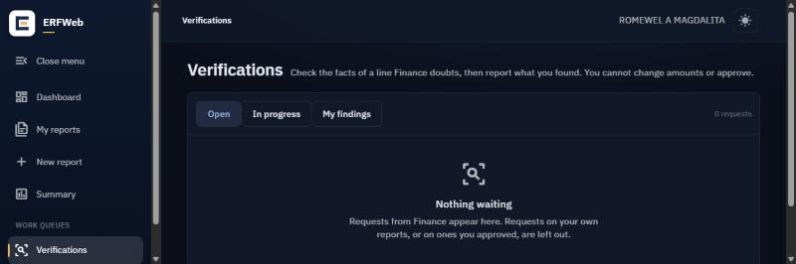
- Click Verifications in the left menu.
- On Open, read the request: the report, the expense line, and Finance: what Finance doubts.
- Click the request to open the report, then click Pick up on its Verification card. The request moves to In progress and is yours; other verifiers no longer see it in the pool.

Step 2: Check the line and record your finding
- Open the report from In progress to see the line, its receipt scans and the R47.
- Check the facts with the people or records involved.
- On the Verification card, click Record finding. The Record your finding window opens.
- Pick one:
Finding | When | Note
Verified | The facts check out | Optional
Verified with note | It checks out, with something Finance should know | Required
Not verified | It does not check out; Finance will refer it to Level 2 | Required
- Write What did you find? and click Record finding.
Your finding is final. Your notes go to Finance and Level 2; the employee sees the finding but not your notes.

After your finding
- Verified or Verified with note: the request closes. Finance carries on and can clear the report for payment once receipts are in. Finance and the employee are notified.
- Not verified: the request goes back to Finance, who queries the Level 2 signatory. Level 2 lets the line through, returns the report to the employee, or rejects it. You are told Level 2's decision.
The request then sits under My findings.

Common problems
What you see | What to do
Nothing waiting on Open | No requests right now, or the only ones are on your own reports or reports you approved
A request disappeared from Open | Another verifier picked it up first
Record finding stays off | Verified with note and Not verified need a note under What did you find?
A message that the request changed | Someone acted on it at the same time; the page reloads, check it again
You recorded the wrong finding | A finding cannot be changed; tell Finance, who can query Level 2

